**Cementing under High Temperature and High Pressure (HTHP) Conditions: a Fully Coupled Porothermoelastic Solution Using Plug and Abandonment (P&A) as Case Studies**

Yunxing Lua & Andrew P. Bungera,b,*

a Department of Civil and Environmental Engineering, University of Pittsburgh, United States of America.

b Department of Chemical and Petroleum Engineering, University of Pittsburgh, United States of America.

* Corresponding author. Tel.:+1 412-624-9875; Fax: +1 412-624-0135

E-mail address: bunger@pitt.edu

1. Introduction

Properly designed and executed cementing operations is important as it is widely applied across the various earth science-related geotechnical applications, such as radioactive waste disposal, deep-well plug and abandonment (P&A), drilling and completion in unconventional reservoir, Enhanced Geothermal (EGS) reservoir, and carbon capture, utilization and storage (CCUS)(Gruber et al., 2021; Hargis et al., 2021; Koťátková et al., 2017; Olson et al., 2015; Vrålstad et al., 2019). A successful cementing job will avoid the unnecessary deficiencies during the life circle of each project which will make the project more environment friendly and improve the system efficiency. Despite the advancements in technological development of cementing materials over the last several decades, the quality of cementing is always associated with some deficiencies mainly due to the harsh environments where cement is placed (Ahmed et al., 2020; Allahvirdizadeh, 2020; Kiran et al., 2017). Taking the P&A as an example, over the years and across companies, the upper range of the reservoir’s pressure and temperature have been pushing up to 40000 psi and 600 F (DeBruijn et al., 2008; Khalifeh et al., 2020). However, the cement is originally designed for low temperature and low pressure conditions, and under such harsh conditions, its stability over an extended period of time is unknown. To leverage this problem, extensively pioneering researches have beening focusing on reinforcing the cement by adding various additives, which is aiming for providing a better mechanical and hydraulic properties thus hoping for maintaining the system integrity under the extreme conditions (Cai et al., 2022; Ge et al., 2018; Katende et al., 2020; Krakowiak et al., 2018; Massion et al., 2021; Massion et al., 2022; Qin et al., 2021; Samarakoon et al., 2022).

However, the identifications of the “better” mechanical and hydraulic properties of cement under the scenario of high temperature and high pressure (HTHP) are still unclear and it does require a more comprehensive and thorough study to highlight the challenges associated with HTHP cementing so a right solution can be developed to suit these challenges. Known as the cementitious saturated porous material with permeability ranges from mili-darcy to nano-darcy (Banthia et al., 1989; Goto et al., 1981; Meng et al., 2021; Picandet et al., 2011), the cement’s behavior can be heavily influenced by the thermo-hydraulic-mechanical (THM) coupling in the porous space, especially when it is experiencing a large temperature and pressure variations. Within the permeability range mentioned above, a very lager pore pressure could be induced by the THM coupling and the pore pressure will be progressively reestablished over the time, which will also lead to the changing of the effective stress and increase the possibility of shear failure, hydraulic fracturing or even tensile failure (Ghabezloo et al., 2010). While THM coupling phenomena in the porous media has been studied by considerable researchers, their applications have been mainly focusing on the wellbore stability during drilling and fluid injection into borehole (Detournay et al., 1988; Gao et al., 2017; Song et al., 2019; Tao et al., 2010; Zhou et al., 2009). The THM coupling effect in the cementing designs and operations has rarely been properly considered and fully investigated under the HTHP conditions, which could result in jeopardizing the cementing integrity and lead to many serious consequences. More importantly, this THM coupling related issues could not be addressed by any of the current available additives, because none of them can change the intrinsic nature, i.e. the porous structure, of the cement.

To include these mutual interactions between thermal, hydraulic and mechanical systems in the non-isothermal conditions, Biot (Biot, 1977) firstly extended the tradition theory of poromechanics and include the uncoupled thermal effects by incorporating the thermos-molecular diffusion and dynamic forces using the variational Lagrangian thermodynamics approach. Later on, the thermal diffusion process was coupled in solid and fluid deformation by Derski (1979), as well as others (Bear et al., 1981; Kurashige, 1989; Smith et al., 1993). The abovementioned porothermoelastic analytical solutions are obtained by neglecting the non-linear term associated with connective heat transfer thus it is called as linear porothermoelastic model that is especially prevailing for the low permeability material (Chen et al., 2005; Delaney, 1982; Gomar et al., 2014; Wang et al., 2003). Within the framework of linear porothermoelasticity, substantial studies have been performed for coupled THM behavior of isotropic porous media to understand the mechanism of relative cases, but most of the work are assuming the fluid flux and heat flux are dominated by the pore pressure gradient and thermal gradient, respectively (Ghassemi et al., 2002; Ghassemi et al., 2009; Valov et al., 2022). That is to say, as shown in Eq.1 and Eq.2, the thermo-osmosis denoted by (fluid flex generated by thermal gradient) and mechano-caloric effects denoted by (heat flux generated by pore pressure gradient) are neglected. Noted that the mechano-caloric coefficient is also known thermal filtration coefficient (Cheng, 2016). However, as for porous material with low permeability, these two effects actually play important roles (Gonçalvès et al., 2010; Roshan et al., 2015; Trémosa et al., 2010). For example, Carnahan (1983) has shown that the thermo-osmosis flow through kaolinite can be two orders of magnitude higher than Darcy’s flow near the nuclear waste repository. Thus, when designing the cementing under the HTHP conditions, both the thermos-osmosis and mechano-caloric effects should be taken into considerations. To our best knowledge, under the HTHP conditions, their influences on the cement integrity are still unclear (is denoting for the fluid flux and is the heat flux).





By introducing so-called fully-coupled porothermoelastic model which is incorporating both of the thermo-osmosis and the mechano-caloric (thermal filtration) effects, dubbed here as “porothermoelastic-osmosis-filtration” (PTEOF), the present work used primary cementing in P&A as an example to highlight the cementing challenges that associated with HTHP conditions by considering the porous intrinsic nature of cement and its related THM coupling phenomenons. The motivations of creating the PTEOF model is to have a comprehensive understanding of the cement’s behaviors under the HTHP and to build up a general framework and solutions for future cementing studies and analysis. Drawing on the important contributions of Sarout et al. (2011) on modifying the theory of linear chemo-poroelasticity into a convenient form whereby the interpretations of the phenomenological parameters can be clarified, this paper will not only include a detailed parametric studies of PTEOF, but also it will include an important discussion of the implications of these results and provide the guidance from a new perspective of design the cementing under HTHP conditions.

2. Model Basics

Following the sign convention in Detournay et al. (1988), the positive stress is considered to be tensile within the present work. Based on the fundamental work of Cheng (2016) and Wang (2017), the constitutive equations for linear porothermoelasticity are written as follows:

 where 

whereandis volumetric strain tensor and total stress tensor, respectively. is the variation of fluid content per unit volume, is entropy density,is pore pressure change from virgin pore pressure and is temperature change from the reference temperature. The material constants include the drained bulk modulus tensor, Biot effective stress coefficient, Skempton pore pressure coefficient, coefficient of volumetric thermal expansion of porous media frame , coefficient of volumetric thermal expansion of variations in fluid content in the solid-fluid system, andrepresents the specific heat of the porous medium at the reference temperature. From the constitutive equations, it shows that the deformation of the solid frame is caused by the effective stress and the temperature change. The fluid phase in the porous medium is not only deforming with the solid frame, but at the same time, driven by pore pressure gradient and thermal forces, causing the pore fluid entering or leaving the solid frame of unit volume. Last, the stress and temperature change will cause the change of the entropy of the porous system based on the generalized-energy relation. The entropy density is therefore becoming a function of volumetric strain of the solid frame and fluid content and the change of temperature. Thus, the constitutive equations relate and couple volumetric strain, fluid content and energy variables  with total stress, pore stress and temperature variables with the materials constant. Noted that one of these volumetric response that Eq. 3 shows can also be obtained from contraction on Eq. 4.







Based on quasi-static equilibrium (Eq.5) and the strain-displacement relations (Eq.6) and by substituting both transport laws (Eq. 1 and Eq. 2) into the mass balance equations (Eq.7 and Eq.8), the fully coupled diffusion equations (Eq. 9 and Eq. 10) could be obtained. These two diffusion equations indicate that both fluid flux and heat flux are not only dominated by the Darcy’s law and Fourier’s law, but also they are influenced by the thermal osmosis effect and thermal filtration effect. This is also where porothermoelastic-osmosis-filtration (PTEOF) so called fully coupled model roots in. One of the motivations to build up these fully coupled model is to facilitate the further studies and analysis. For example, under some circumstances where thermal osmosis or thermal filtration is not considered important, it can always take the corresponding coefficient to zero to simplify the model.









3. PTEOF solution for the primary cementing in P&A

3.1 Problem descriptions and boundary conditions

In light of the present work will showcase the PTEOF model by using the primary cementing in P&A cases where the length of the primary plug is usually 50 to 100 times larger than its diameter (Eshraghi, 2013), it is appropriate to apply the generalized plane-strain assumption where the pore pressure and thermal diffusions only appear in the isotropic plane that perpendicular to the length axis of the plug which is fully saturated. In line with the loading decomposition scheme proposed by Detournay et al. (1988) in the poroelasticity, the PTEOF model could be decomposed into three sub-loading cases to simplify the analysis, i.e. pore pressure loading (), temperature loading () and isotropic far-field stress loading (), where the superscript i is denoting by the stress field that induced by the loading mode j. Thus, the boundary conditions at the outside surface of the primary cement plug for each of the loading modes can be written as follows (the subscript f is denoting by formation, subscript c is denoting by cement). Since the PTEOF model is linear, the principle of superposition will be used as final step to obtain the final solution.

* Mode 1: , and 
* Mode 2: , and 
* Mode 3: , and 

3.2 Solution to the fully coupled diffusion equations

The solution method starts with obtaining a general solution of the fully coupled diffusion equations (Eq.9 and Eq.10). Noting that the plane-strain assumption will lead to the conclusion that fluid and thermal transport will be only directed along the radial direction only in the cylindrical coordinates system. Then the first step is to eliminate  and in the diffusion equation Eq.9 and Eq.10 by substituting the constitute equations (Eq.3), this results in a new form of coupled diffusion equations could be expressed by Eq.11 and Eq.12.





Next by combining the Eq.4 to Eq.6 and taking the body force to zero, an extended form of the classical Navier equations about be obtained:



Drawing on the important contributions of Sarout et al. (2011) on modifying the theory of linear chemoporoelasticity into a convenient form whereby the interpretations of the phenomenological parameters can be clarified, we herein by using the irrotational field assumptions to simplify the process of solve the Navier equations. When displacement field is irrotational, i.e. is the gradient of a scaler, one can integrate Eq. 13 to obtain



Where  and 

Thedoes not depend on the spatial coordinates and it is a spatially uniform function that is often taking to zero for infinite or semi-infinite domain (Detournay et al., 1993). But in the case of the primary cementing in P&A, thewill not be taking as zero here. Next, by substituting Eq. 14 into Eq. 11 and Eq. 12, thecould be eliminated and it could have the coupled diffusion equations in other form as shown in Eq. 15.



Where















The diffusion equations shown in Eq.15 are coupled in terms of T and p, which can be transformed into uncoupled problems in terms of  and by using the Eigen decomposition approach developed by Sarout et al. (2011). This methodology is starting with obtaining two eigenvalues  and  of matrix. Then the Eigen-decomposition theorem (Weisstein, 2002) will allow us to define a transition matrixwhich is composed of eigenvalues and eigenvectors of , and temperature and pore pressure can be expressed as follows



Where





This transition leads directly to an uncoupled system of diffusion equations for the given by where 

Then by applying the Laplace transform to the Eigen function(Eq.18), it becomes an ordinary differential equation in terms of variable, where the is function of the coordinators in cylindrical system ρ, and the Laplace parameter s and the’s eigenvalue.

 Where 

Therefore, the original coupled diffusion equations (Eq.15) has been lead to the zeroth-order modified Bessel equation with the general solution as (Eq.19), where and  are unknowns that will be determined based on the boundary conditions. And are the zeroth-order modified Bessel functions of the first and second kind, respectively.



The symmetry conditions of the primary cementing in P&A will ensure the equals to zero, thus the pore pressure and temperature profile in Laplace domain could be expressed as follows:





Within the framework of plane-strain conditions and irrotational field, the displacement  could be obtained by integrate the Eq.14. At the same time, the strain-displacement relationship could be expressed as follows:



Where  and 

Up to now, there are totally three unknowns, i=1,2,3 in the system. The first two unknown  and are coming from the coefficient of zeroth-order modified Bessel functions of the first kind and the third unknown is coming from the spatially uniform function from Eq.14 in Laplace domain. In the process of deriving the above expressions for the pore pressure, temperature and radial total stress (all in Laplace domain), we have three equations for these three unknowns (shown in Eq.23).



Where















So that given a value of s, thecan be readily computed, thus the solution then can be numerically inverted to the time domain using Stehfest’s method (Stehfest, 1970), which has been proved to be efficient in poroelastic problems and its details are shown in Appendix B.

4. Numerical Analysis and Discussion

The notations are used for the modeling are summarized Table 1. All of their values are obtained from the literatures and shown as below. The temperature difference between the formation and cement is assigned as; the virgin pore pressure of the formation is setup as pa and far-field isotropic stress is setup as pa (Snee et al., 2018; Xu et al., 2015; Zoback et al., 2003). In this section, we will firstly discuss the pore pressure profile and temperature profile that induced by three different loads, respectively. Lastly, the superposition results of the effective stress will be discussed.



4.1 Pore pressure responses to three different loadings

In the most of classical poromechanics analysis, the evolution of pore pressure in response to different loadings is calculated and interpreted. It is therefore of interest to firstly plot the evolution of pore pressure under three different loading modes given the boundary conditions that defined in the last section, and the influence of the factors of interest on the pore pressure will be conducted to illustrate the PTEOF.



Figure 1a. Pore pressure change due to mode 1 loading, where the curves grade from gray to black as time increases



Figure 1b. Pore pressure change due to mode 2 loading, where the curves grade from gray to black as time increases



Figure 1c. Pore pressure change due to mode 3 loading, where the curves grade from gray to black as time increases

Fig.1a and 1b illustrate the evolution of pore pressure profile along the radius in response to mode 1 loading (pore pressure loading) and mode 2 loading (temperature loading). Under the mode 1 loading, it is similar to the classical diffusion process, the pore pressure near the surface (r=1) is instantly raised to the level of pore pressure loading and then the pore pressure is gradually diffusing towards in the center (r=0). However, in contrast of gradual and smooth diffusion process, the pore pressure induced by mode 2 firstly peaks near the surface area. At the surface, the pore pressure returns to zero due to the boundary conditions setup. The pore pressure, however, decreases toward the inner core (because of the slow diffusion progress due to low hydraulic conductivity) hence a peak profile is developed. As time progresses, the pore pressure peak declines due to fluid diffusion, and at the same time, the inner core becomes heated as well and so the peak is moving toward to the center. At even larger time, when the entire specimen is heated but the pore pressure is not yet dissipated due to the small fluid diffusivity. As time further increases, the entire pore pressure dissipates and return to zero everywhere. For the pore pressure that induced by the mode 3 (isotropic far-field stress), as shown in Fig.1c, it is firstly arrives the highest value right after the loading (again, pore pressure at surface reduces to zero due to the boundary conditions setup), but it gradually declines to zero due to the dissipation process as the time process. It is noticeable that the magnitude of the pore pressure induced by mode 3 is much smaller compared to the pore pressure induced by mode 1 and mode 2. Even at their highest level which is right later the loading is applied, the ratio of mode 3 induced pore pressure over the mode 1 and mode 2 induced pore pressure is around 0.01%-0.02%. This is also in line with the findings from the classical pure poroelastic model that Detournay et al. (1988) concluded. It indicates that the undrained loading effect as a short-term characteristic of low permeability rock does not increase much pore pressure.

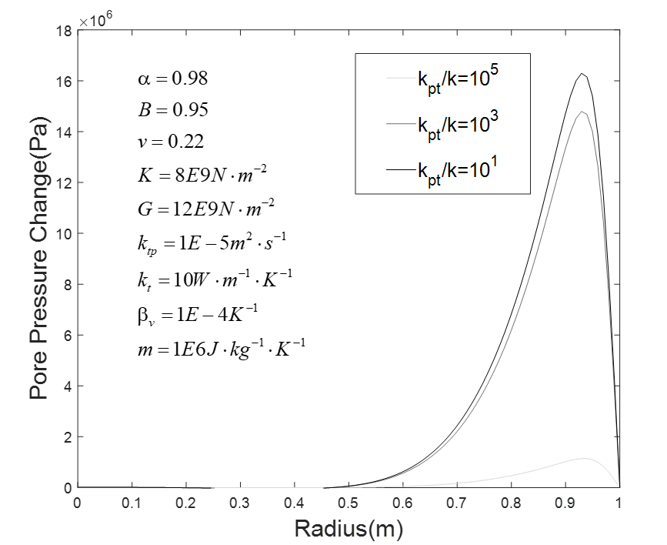

Figure 2. Various ratio of (thermo-osmosis’s influence) on the induced pore pressure (days)

Since the peak pore pressure usually occurs at the early-time, we will use the smaller time at days after loading to illustrate the thermal osmosis effect on the induced pore pressure profile. Three different ratios (1, 103, 105) of are selected to show the different developments of the temperature induced pore pressure (Figure 2). Recalling the definition of the thermal-osmosis coefficient which can be understood as the passage of a fluid that is driven by a temperature gradient but again the hydrostatic pressure (Denbigh, 1949). Taking the early time as example, all three cases are showing a peak pore pressure near the surface region. However, the magnitude of the peak induced pore pressure is reduced when the thermos-osmotic coefficient is significantly larger than the hydraulic conductivity (i.e., =105). These phenomena indicates that a large thermos-osmotic coefficient can help to reduce the temperature induced pore pressure, which will fortify the effective stress in the cement and reduce the possibility of failure.

4.2 Temperature response to three different loadings

The temperature profiles under three different loadings are firstly studied here (the value of the input parameters are stated at the beginning of this section), and then the thermal filtration effect on the evolution of temperature will be studied later in this section. Firstly, the temperature evolution under the loading mode 2 is shown in Figure 3. As the time proceeds, temperature is increasing monotonically from surface towards the inner core of the plug and finally arrives the equilibrium at larger time.

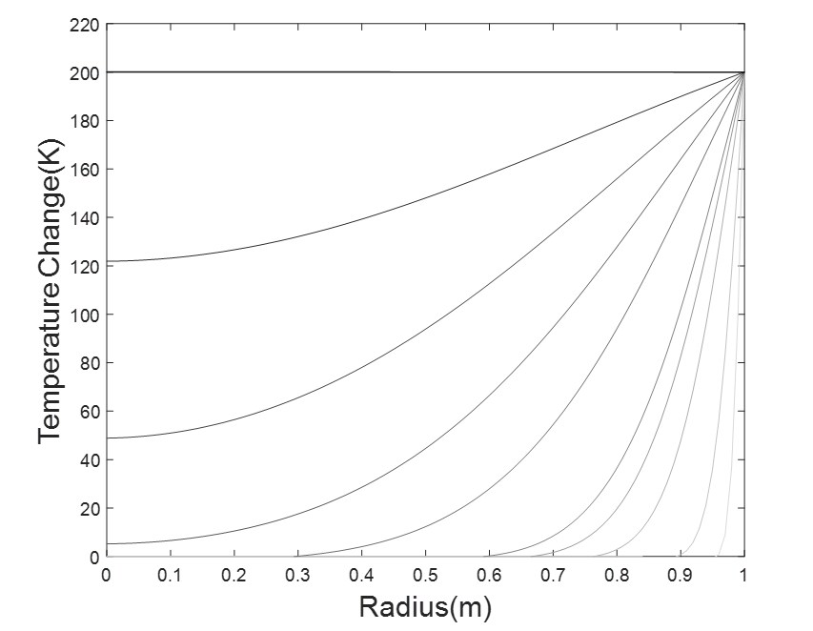

Figure 3. Temperature profile development under the loading mode 2, where the curves grade from gray to black as time increases

Three different ratios of thermal conductivity over the thermal filtration coefficients are selected to show their impact on the temperature profile that is changed by the pore pressure gradient. As shown in Figure 4, among the three selected ratios, the maximum temperature difference induced by the pore pressure gradient is within 1 degree Kalvin. Furthermore, when the thermal conductivity is significantly larger than the thermal filtration coefficient (=105), the induced temperature difference are negligible under the current model settings and input.

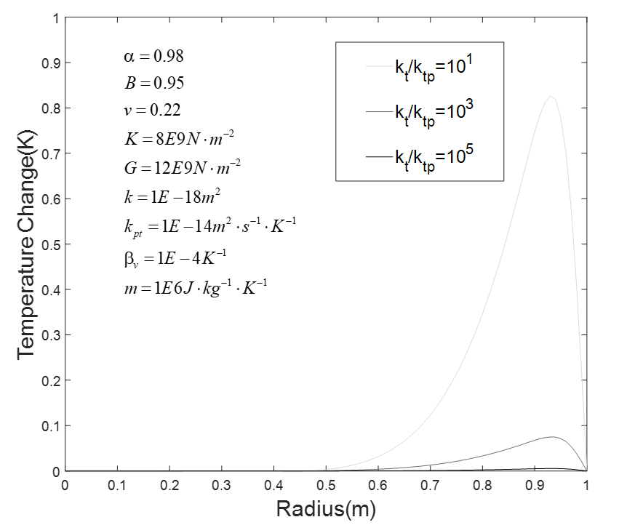

Figure 4. Various ratio of (thermal filtration’s influence) on the temperature profile change

4.3 Effective Stress

Many pioneering researches have shown that the effective stress is a key factor to control the behaviors of the porous medias in the geotechnical and earth applications (Khalili et al., 2004; Skempton, 1984). Specifically, the increase pore pressure will reduce of effective stress which can increase the possibility of many types of failures. Thus, appropriate estimation and calculation of total effective stress will greatly enhance the understanding of the behaviors of the porous system. As shown in figure 5 where the total effective radial stress (after superposition from three loading modes) is plotted (again, tensile is positive). After the cement is placed under the boundary conditions that setup previously, the induced pore pressure will reduce the radial effective stress near the surface region, and as it diffuses towards the inner core, the effective stress will be further reduced and the tensile region will be created inside the core. At the later stage, the induced pore pressure will be dissipated, the radial total effective stress returns to compressive again. This demonstration of the whole process of PTEOF model with given input indicates that cementing under the high temperature and high pressure conditions will lower the effective stress and even induced the tensile effective stress as the response to the induced high pore pressure diffusing inward. Based on the theory of effective stress mentioned above, the phenomenon will increase the possibility of failure of the cement under HTHP conditions and thus will cause more severe sequences.



Figure 5. Total effective stress of cement under the conditions of HTHP, where the curves grade from gray to black as time increases (boundary conditions and input values of each parameter are stated at the beginning of this sections)

4.4 Fully parametric studies by heat map

It is worth to mention that the system behaviors discussed in the last section are depending on the different values of input parameters and the mutual interaction and group effect among them. If some of these parameters are taking different values, the results can be much different. Thus, these features will be investigated and discussed in this sections.

4.4.1 Heat map by individual parameter plot

To firstly grasp a full figure of how each parameter will individually influence the system behavior in the PTEOF model, a heat map is thus created. The heat map is a graphical representation of data contained in a matrix where values are depicted by color (DeBoer, 2015). In our work, instead of showing a massive data sets that are complicated and difficult to interpret, the heat map is tailor-made here into a concise format that is easy to understand. The data in the heat map are generated based on the constitutive equations and the loading decomposition scheme that discussed in the section two. The eleven different parameters in the constitutive equations are firstly assumed as independent variables (their mutual interactions and group effects will be discussed in the next section). Each variable is assigned with three different values, namely lower, middle and higher (the specific values are listed in Table 2). The algorithm behind this heat map, which is shown in Figure 6, is changing only one parameter each time while the rest of them are maintained as the same. Thus, 11 independent parameters will requires 311 times of iterations. For each ease, the positive value of total effective stress (tensile), if it exists, will be found and stored in the matrix for the heat map plotting.

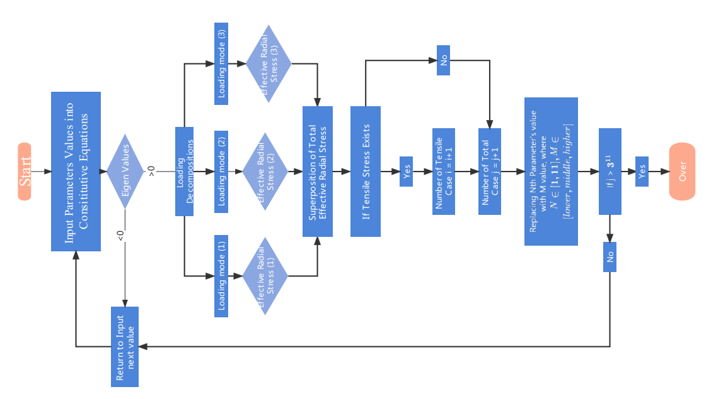

Figure 6. The Algorithm that is used to construct the heat map

Based on the algorithm that shown in the flowchart (Figure 6), the heat map is finally constructed in Figure 7. Each number in the small block is representing the percentage of the cases of tensile radial effective stress associate with the corresponding parameter among all the cases and the side color bar indicates the scale of the probability. A general trend can be found from this heat map that a higher values of  and lower value of and will increase the probability of tensile radial effective stress generations. A very interesting phenomenon can be found here, opposite of the current cement designing principles – the lower hydraulic conductivity, the better system behavior, our results show that the lower permeability will actually increase the probability of the tensile case which is considered as detrimental to the system. This is mainly due to that under the framework of porous media, the lower permeability will clog the pathway of the pore fluid diffusion when the pore pressure is build up within the cement because of the HTHP conditions. The clogged porous system will accumulate the pore pressure that can not be dissipated and the effective stress will be thus reduced and finally jeopardizing the whole system. That is to say, blindly pursing the low permeability regardless the intrinsic properties of the cement itself will victimize the whole system instead. The best solution for cementing design under HTHP is to main the permeability at certain ranges which can achieve the sealing function, but at the same time, it will not cause the unnecessary damage that induced by the excessive pore pressure.



Figure 7. Heat map of how each parameter will individually influence the system behavior (each number in the small block is representing the percentage of the cases of tensile radial effective stress associate with the corresponding parameter among all the cases and the side color bar indicates the scale of the probability)

It also worth mentions that the specific heat capacity is rarely get much attention in the previous research in HTHP cementing design. However, based on our results, it does play a very important role which is similar to the role of thermal conductivity as a large specific heat capacity will slow down the heat transfer process. Thus the thermal induced pore pressure build up progress will be delayed and the pore fluid will have more time to dissipate.

Table 2. Lower, middle and higher value define in the Figure 6 and Figure 7 (the unit of each parameter is same as the unit defined in Table 1)

|  |  |  |  |
| --- | --- | --- | --- |
|  | Lower Value | Middle Value | Higher Value |
|  | 0.25 | 0.55 | 0.95 |
|  | 0.18 | 0.58 | 0.98 |
|  | 1E-6 | 1E-5 | 1E-4 |
|  | 4E9 | 8E9 | 16E9 |
|  | 6E9 | 12E9 | 24E9 |
|  | 0.12 | 0.22 | 0.32 |
|  | 1E-18 | 1E-17 | 1E-16 |
|  | 1E-6 | 1E-5 | 1E-4 |
|  | 1E-15 | 1E-14 | 1E-13 |
|  | 1E5 | 1E6 | 1E7 |

4.4.2 Heat map by new proposed parameters plot

Although the heat map shown in Figure 7 gives a full picture of how each parameter will individually influence the system behaviors, the mutual interactions of different parameters and their group effect can not be analyzed from it. To solve this problem, scaling analysis is one the classical methods. It is usually used to reducing complex physical problem to a simpler version prior to obtaining a quantitative answer and can grasp the effects of various physical phenomena at the same time (Abbas et al., 2013). We indeed can follow the typical procedures to conduct the scaling analysis to investigate the mutual interaction and group effect of the PTOEF model. However, the new dimensionless numbers that is resulting from the scaling process is often in a very complicated expressions and lacking of a direct meaning at the physical level, which can be very ambiguous in terms of many engineering applications. Thus, inspired by the spirit of the methodology of scaling analysis, we here adapted to manually compose several new composite numbers with clearer physical meaning and then reconstruct a new heat map that can account for the mutual interactions and group effects among these different parameters. Thus, two new parameters are hereby proposed as follows:



Concluding from the first heat map (Fig. 7), there are four important parameters  will contribute to the tensile stress. Thus, the first dimensionless numberwill consist four of them and then add the in the numerator to complete the non-dimension process (noted that the previous analysis has shown that the thermal-osmosis also plays important role of reducing the pore pressure in this system). This new proposedmainly contains the hydro-thermal properties of the porous media. It is thus named as Hydro-Thermal Non-Dimensional parameter (HTND). The second proposed parameter, which is not non-dimensionless though, is based on the nature of the constitutive equations. As shown in Eq.3, the presence of is always associated with. Furthermore, by the similar definitions of theand, it is reasonable to bundle both of them together to create the second number, dubbed here as Bulk-Biot-Skempton (BBS) parameter.

Givenandthe remaining three parameters, a new heat map can by generated with a similar algorithm shown in the previous flowchart (Figure 6). From the new heat map (Figure 8), it is clearly showing that when the HTND parameteris taking the higher value, the probability of the induced tensile case is 100%. However, whenis taking middle value and lower value, there is no induced tensile case at all among the rest of the cases. This indicates that when these five important parameters are grouping together, their influence over the system is absolutely dominating. It is also evidenced by that the probability distributions of the rest parameters are all around 33%, which are all most all evenly distributed. It means that when this powerfuldimensionless number is dominating the system, the influence of all other parameters are very trivial. At the same time, it can be easily tell that the shear modulus and Poisson’s ratio, which are considered as two of the most important mechanical properties, are having very limited contribution to the system behavior when the high value of the HTND parameter is presenting. That is to say, when designing the cement under the HTHP conditions, the highest priority should be given to the HTND parameter, rather than the two mechanical components (shear modulus and Poisson’s). This is also challenging the current HTHP cementing design principles that are always prioritizing to making the cement stronger and more ductile, which is hope for the cementing system will thus have more resilience and has less possibility to failure. It actually may not help to maintain the cement integrity under the HTHP conditions.

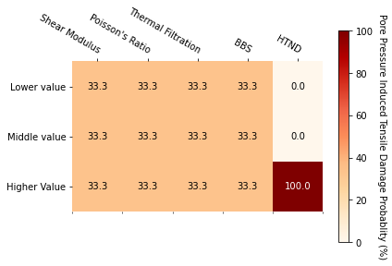

Figure 8. Heat map with two new proposed parameters - BBS and HTND (each number in the small block is representing the percentage of the cases of tensile radial effective stress associate with the corresponding parameter among all the cases and the side color bar indicates the scale of the probability)

5. Conclusions

Using the primary cementing in P&A as example, the fully coupled porothermoelastic-osmosis-filtration (PTEOF) model is presented here. It has been demonstrated that under HTHP conditions, the induced pore pressure in the low permeability material such as cement can be very large to greatly reduce the effective stress and even induce the tensile stress, which will increase the probability to failure. Furthermore, by adapting the scaling analysis approach and proposing two new parameters HTDN () and BBS (), it shows that under the HTHP conditions, rather than the mechanical properties such as shear modulus and Poisson’s, the mutual interaction and group effects among these factors of  are the dominating parameters to control the behaviors of the porous media with low hydraulic conductivity.

More importantly, the implications of our results are challenging the prevailing HTHP cementing principles and providing a new perspective of design and guidance by addressing the porous intrinsic nature of the cement. The current cementing improvement practices, which are adding different additives into cement to enhance its mechanical properties, will not change the fact that the new additive mix is still a porous media. The new additive can change the pore space into various sizes even into nano-scale though. However, without considering the underlying physical principles governing the mechanical behaviors under the framework of porous media, it sometimes will jeopardize the whole system instead. Our results indicate that when cementing under HTHP conditions, the mechanical properties such as shear modulus and Poisson’s ratio may not be the most important parameters to maintain the integrity of cement and its permeability is not always the lower the better. Instead, when the permeability is too low, the boundary conditions (HTHP) induced pore pressure doesn’t have enough pathway and time to dissipate and the clogging pore fluid will greatly reduce the effective stress to damage the system, which is totally infringe the idea of having such low permeability. Thus, the permeability of cement under HTHP should be design at a certain range, which is enough for sealing the pathway but not too much for inducing the excessive pore fluid damage.

Another important implications from our results to guide the cementing under HTHP is that instead focusing on enhancing the mechanical properties, thermal properties such as thermal conductivity, specific heat capacity, thermal expansion coefficient ratio and the thermo-osmosis coefficient also deserves more attention. Our results show that the thermal induced pore pressure can be large enough to reduce the effective stress, and these thermal induced pore pressure is mainly due to the thermal transfer process is faster than the pore fluid dissipation process. Thus, slowing down the thermal transfer process becomes a key step to preventing it from happening. Certainly, reducing the thermal conductivity is the most direct method to achieve this goal. However, our results show that increasing the specific heat capacity is another efficient way to slow down the pore pressure build up progress. This implication provide a totally new perspective of creating a phase-change cement with high volume specific heat capacity but low thermal conductivity that is specially designed for HTHP conditions, which is having very promising and wide applications.

Acknowledgments

This research is supported by the Swanson School of Engineering (summer research intership program) and the National Academy of Science and Mathematics Gulf Research Program (NASEM-GRP) grant # 10002358 and the Project Research Team Members: Mileva Radonjic from Oklahoma State University, Raissa Ferron group from University of Texas Austin, Ipsita Gupta group from Louisiana State University and Pierre Cerasi from SINTEF. Thanks go to Charles Hager (PITT) for the outstanding technical contributions. We are grateful for the support of our entire research group who make the Hydraulic Fracturing Lab here at University of Pittsburgh and finally the postdoc scholar and graduate students from NASEM GRP funded project: Cindy Cao (OSU), MercyAchang (OSU), Cody, Massion (OSU), Vamsi Vissa (OSU), Tamitope Ajayi (LSU), Farzana Rahman (UTA) and especially Hope Asala, who is no longer with us due to a tragic accident.

Appendix A: Table 1. Notations

|  |  |  |
| --- | --- | --- |
| Symbol | Definition | Unit |
|  | Biot effective stress coefficient | --- |
|  | Drained thermoelastic effective stress coefficient | N⋅m-2⋅K-1 |
|  | Skempton pore pressure coefficient | --- |
|  | Coefficient of volumetric thermal expansion of solid | K-1 |
|  | Coefficient of volumetric thermal expansion of porosity | K-1 |
|  | Coefficient of volumetric thermal expansion of fluid | K-1 |
|  | Coefficient of volumetric thermal expansion for variation in fluid content | K-1 |
|  | Drained coefficient of volumetric thermal expansion of porous medium frame | K-1 |
|  | Specific heat of the porous medium at reference temperature | J⋅kg−1⋅K−1 |
|  | Fluid flux | m⋅s−1 |
|  | Heat flux | J⋅m−2⋅s−1 |
|  | Permeability | m2 |
|  | Thermal conductivity | W⋅K−1⋅m−1 |
|  | Mechano-caloric coefficient (Thermal filtration) | m2⋅s−1 |
|  | Thermo-osmosis coefficient | m2⋅s−1⋅K−1 |
|  | Poisson’s ratio | --- |
|  | Drained bulk modulus | N⋅m-2 |
|  | Shear modulus | N⋅m-2 |

Appendix B: Details of Stehfest’s method

For a given function p with Laplace transform, Stehfest’s method can be expressed as, taking pore pressure for example:



Where the coefficient are given by



Reference

Abbas, S., & Lecampion, B. (2013). *Initiation and breakdown of an axisymmetric hydraulicfracture transverse to a horizontal wellbore.* Paper presented at the ISRM International Conference for Effective and Sustainable Hydraulic Fracturing.

Ahmed, S., Salehi, S., & Ezeakacha, C. (2020). Review of gas migration and wellbore leakage in liner hanger dual barrier system: Challenges and implications for industry. *Journal of Natural Gas Science and Engineering, 78*, 103284.

Allahvirdizadeh, P. (2020). A review on geothermal wells: Well integrity issues. *Journal of cleaner production, 275*, 124009.

Banthia, N., & Mindess, S. (1989). Water permeability of cement paste. *Cement and concrete research, 19*(5), 727-736.

Bear, J., & Corapcioglu, M. (1981). A mathematical model for consolidation in a thermoelastic aquifer due to hot water injection or pumping. *Water Resources Research, 17*(3), 723-736.

Biot, M. A. (1977). Variational Lagrangian-thermodynamics of nonisothermal finite strain mechanics of porous solids and thermomolecular diffusion. *International Journal of Solids and Structures, 13*(6), 579-597.

Cai, W., Deng, J., Luo, M., Feng, Y., Li, J., & Liu, Q. (2022). Recent advances of cementing technologies for ultra-HTHP formations. *International Journal of Oil, Gas and Coal Technology, 29*(1), 27-51.

Carnahan, C. (1983). Thermodynamic coupling of heat and matter flows in near-field regions of nuclear waste repositories. *MRS Online Proceedings Library (OPL), 26*.

Chen, G., & Ewy, R. T. (2005). Thermoporoelastic effect on wellbore stability. *SpE Journal, 10*(02), 121-129.

Cheng, A. H.-D. (2016). *Poroelasticity* (Vol. 27): Springer.

DeBoer, M. (2015). Understanding the heat map. *Cartographic perspectives*(80), 39-43.

DeBruijn, G., Skeates, C., Greenaway, R., Harrison, D., Parris, M., James, S., . . . Temple, L. (2008). High-pressure, high-temperature technologies. *Oilfield Review, 20*(3), 46-60.

Delaney, P. T. (1982). Rapid intrusion of magma into wet rock: Groundwater flow due to pore pressure increases. *Journal of Geophysical Research: Solid Earth, 87*(B9), 7739-7756.

Denbigh, K. (1949). Thermo-osmosis of gases through a membrane. *Nature, 163*(4132), 60-60.

Derski, W. (1979). Equations of linear thermoconsolidation. *Archives of Mech., 31*(3), 303-316.

Detournay, E., & Cheng, A.-D. (1988). *Poroelastic response of a borehole in a non-hydrostatic stress field.* Paper presented at the International Journal of Rock Mechanics and Mining Sciences & Geomechanics Abstracts.

Detournay, E., & Cheng, A. H.-D. (1993). Fundamentals of poroelasticity. In *Analysis and design methods* (pp. 113-171): Elsevier.

Eshraghi, D. (2013). *P&A-status on regulations and technology, and identification of potential improvements.* University of Stavanger, Norway,

Gao, J., Deng, J., Lan, K., Song, Z., Feng, Y., & Chang, L. (2017). A porothermoelastic solution for the inclined borehole in a transversely isotropic medium subjected to thermal osmosis and thermal filtration effects. *Geothermics, 67*, 114-134.

Ge, Z., Yao, X., Wang, X., Zhang, W., & Yang, T. (2018). Thermal performance and microstructure of oil well cement paste containing subsphaeroidal konilite flour in HTHP conditions. *Construction and Building Materials, 172*, 787-794.

Ghabezloo, S., & Sulem, J. (2010). Temperature induced pore fluid pressurization in geomaterials. *arXiv preprint arXiv:1011.6501*.

Ghassemi, A., & Diek, A. (2002). Porothermoelasticity for swelling shales. *Journal of Petroleum Science and Engineering, 34*(1-4), 123-135.

Ghassemi, A., Tao, Q., & Diek, A. (2009). Influence of coupled chemo-poro-thermoelastic processes on pore pressure and stress distributions around a wellbore in swelling shale. *Journal of Petroleum Science and Engineering, 67*(1-2), 57-64.

Gomar, M., Goodarznia, I., & Shadizadeh, S. R. (2014). Transient thermo-poroelastic finite element analysis of borehole breakouts. *International Journal of Rock Mechanics and Mining Sciences, 71*, 418-428.

Gonçalvès, J., & Trémosa, J. (2010). Estimating thermo-osmotic coefficients in clay-rocks: I. Theoretical insights. *Journal of colloid and interface science, 342*(1), 166-174.

Goto, S., & Roy, D. M. (1981). The effect of w/c ratio and curing temperature on the permeability of hardened cement paste. *Cement and concrete research, 11*(4), 575-579.

Gruber, S., & Plank, J. (2021). *Challenges in Cementing Deep Offshore Wells.* Paper presented at the Vietnam Symposium on Advances in Offshore Engineering.

Hargis, C. W., Chen, I. A., Devenney, M., Fernandez, M. J., Gilliam, R. J., & Thatcher, R. P. (2021). Calcium Carbonate Cement: A Carbon Capture, Utilization, and Storage (CCUS) Technique. *Materials, 14*(11), 2709.

Katende, A., Lu, Y., Bunger, A., & Radonjic, M. (2020). Experimental quantification of the effect of oil based drilling fluid contamination on properties of wellbore cement. *Journal of Natural Gas Science and Engineering, 79*, 103328.

Khalifeh, M., & Saasen, A. (2020). *Introduction to permanent plug and abandonment of wells*: Springer Nature.

Khalili, N., Geiser, F., & Blight, G. (2004). Effective stress in unsaturated soils: Review with new evidence. *International journal of Geomechanics, 4*(2), 115-126.

Kiran, R., Teodoriu, C., Dadmohammadi, Y., Nygaard, R., Wood, D., Mokhtari, M., & Salehi, S. (2017). Identification and evaluation of well integrity and causes of failure of well integrity barriers (A review). *Journal of Natural Gas Science and Engineering, 45*, 511-526.

Koťátková, J., Zatloukal, J., Reiterman, P., & Kolář, K. (2017). Concrete and cement composites used for radioactive waste deposition. *Journal of environmental radioactivity, 178*, 147-155.

Krakowiak, K. J., Thomas, J. J., James, S., Abuhaikal, M., & Ulm, F.-J. (2018). Development of silica-enriched cement-based materials with improved aging resistance for application in high-temperature environments. *Cement and concrete research, 105*, 91-110.

Kurashige, M. (1989). A thermoelastic theory of fluid-filled porous materials. *International Journal of Solids and Structures, 25*(9), 1039-1052.

Massion, C., Radonjic, M., Lu, Y., Bunger, A., & Crandall, D. (2021). *Impact of Graphene and the Testing Conditions on the Wellbore Cement Mechanical and Microstructural Properties.* Paper presented at the 55th US Rock Mechanics/Geomechanics Symposium.

Massion, C., Vissa, V. S., Lu, Y., Crandall, D., Bunger, A., & Radonjic, M. (2022). Geomimicry-Inspired Micro-Nano Concrete as Subsurface Hydraulic Barrier Materials: Learning from Shale Rocks as Best Geological Seals. In *REWAS 2022: Energy Technologies and CO2 Management (Volume II)* (pp. 129-138): Springer.

Meng, M., Frash, L. P., Carey, J. W., Li, W., Welch, N. J., & Zhang, W. (2021). Cement stress and microstructure evolution during curing in semi-rigid high-pressure environments. *Cement and concrete research, 149*, 106555.

Olson, J., Eustes, A., Fleckenstein, W., Eker, E., Baker, R., & Augustine, C. (2015). Completion Design Considerations for a Horizontal Enhanced Geothermal System. *GRC Transactions, 39*, 335-344.

Picandet, V., Rangeard, D., Perrot, A., & Lecompte, T. (2011). Permeability measurement of fresh cement paste. *Cement and concrete research, 41*(3), 330-338.

Qin, J., Pang, X., Cheng, G., Bu, Y., & Liu, H. (2021). Influences of different admixtures on the properties of oil well cement systems at HPHT conditions. *Cement and Concrete Composites, 123*, 104202.

Roshan, H., Andersen, M., & Acworth, R. (2015). Effect of solid–fluid thermal expansion on thermo-osmotic tests: an experimental and analytical study. *Journal of Petroleum Science and Engineering, 126*, 222-230.

Samarakoon, M., Ranjith, P., & Wanniarachchi, W. (2022). Properties of well cement following carbonated brine exposure under HTHP conditions: A comparative study of alkali-activated and class G cements. *Cement and Concrete Composites, 126*, 104342.

Sarout, J., & Detournay, E. (2011). Chemoporoelastic analysis and experimental validation of the pore pressure transmission test for reactive shales. *International Journal of Rock Mechanics and Mining Sciences, 48*(5), 759-772.

Skempton, A. (1984). Effective stress in soils, concrete and rocks. *Selected papers on soil mechanics, 1032*(3), 4-16.

Smith, D. W., & Booker, J. R. (1993). Green's functions for a fully coupled thermoporoelastic material. *International Journal for Numerical and Analytical Methods in Geomechanics, 17*(3), 139-163.

Snee, J.-E. L., & Zoback, M. D. (2018). State of stress in the Permian Basin, Texas and New Mexico: Implications for induced seismicity. *The Leading Edge, 37*(2), 127-134.

Song, Z., Liang, F., Lin, C., & Xiang, Y. (2019). Interaction of pore pressures in double-porosity medium: Fluid injection in borehole. *Computers and Geotechnics, 107*, 142-149.

Stehfest, H. (1970). Algorithm 368: Numerical inversion of Laplace transforms [D5]. *Communications of the ACM, 13*(1), 47-49.

Tao, Q., & Ghassemi, A. (2010). Poro-thermoelastic borehole stress analysis for determination of the in situ stress and rock strength. *Geothermics, 39*(3), 250-259.

Trémosa, J., Gonçalvès, J., Matray, J., & Violette, S. (2010). Estimating thermo-osmotic coefficients in clay-rocks: II. In situ experimental approach. *Journal of colloid and interface science, 342*(1), 175-184.

Valov, A., Golovin, S., Shcherbakov, V., & Kuznetsov, D. (2022). Thermoporoelastic model for the cement sheath failure in a cased and cemented wellbore. *Journal of Petroleum Science and Engineering, 210*, 109916.

Vrålstad, T., Saasen, A., Fjær, E., Øia, T., Ytrehus, J. D., & Khalifeh, M. (2019). Plug & abandonment of offshore wells: Ensuring long-term well integrity and cost-efficiency. *Journal of Petroleum Science and Engineering, 173*, 478-491.

Wang, H. F. (2017). *Theory of linear poroelasticity with applications to geomechanics and hydrogeology*: Princeton University Press.

Wang, Y., & Dusseault, M. B. (2003). A coupled conductive–convective thermo-poroelastic solution and implications for wellbore stability. *Journal of Petroleum Science and Engineering, 38*(3-4), 187-198.

Weisstein, E. W. (2002). Eigen decomposition. [*https://mathworld*](https://mathworld)*. wolfram. com/*.

Xu, S., & Zoback, M. D. (2015). *Analysis of stress variations with depth in the Permian Basin Spraberry/Dean/Wolfcamp Shale.* Paper presented at the 49th US Rock Mechanics/Geomechanics Symposium.

Zhou, X., & Ghassemi, A. (2009). Finite element analysis of coupled chemo-poro-thermo-mechanical effects around a wellbore in swelling shale. *International Journal of Rock Mechanics and Mining Sciences, 46*(4), 769-778.

Zoback, M., Barton, C., Brudy, M., Castillo, D., Finkbeiner, T., Grollimund, B., . . . Wiprut, D. (2003). Determination of stress orientation and magnitude in deep wells. *International Journal of Rock Mechanics and Mining Sciences, 40*(7-8), 1049-1076.